**Large Amount Movement on GL-General Movement on 09-09-2016 at some branches below:**

7594-389400-General Provision for Bad and Doubtful Debts

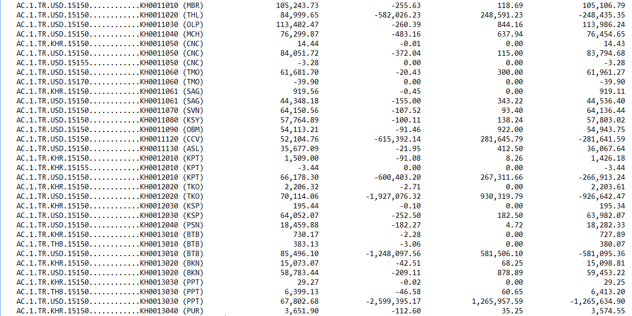 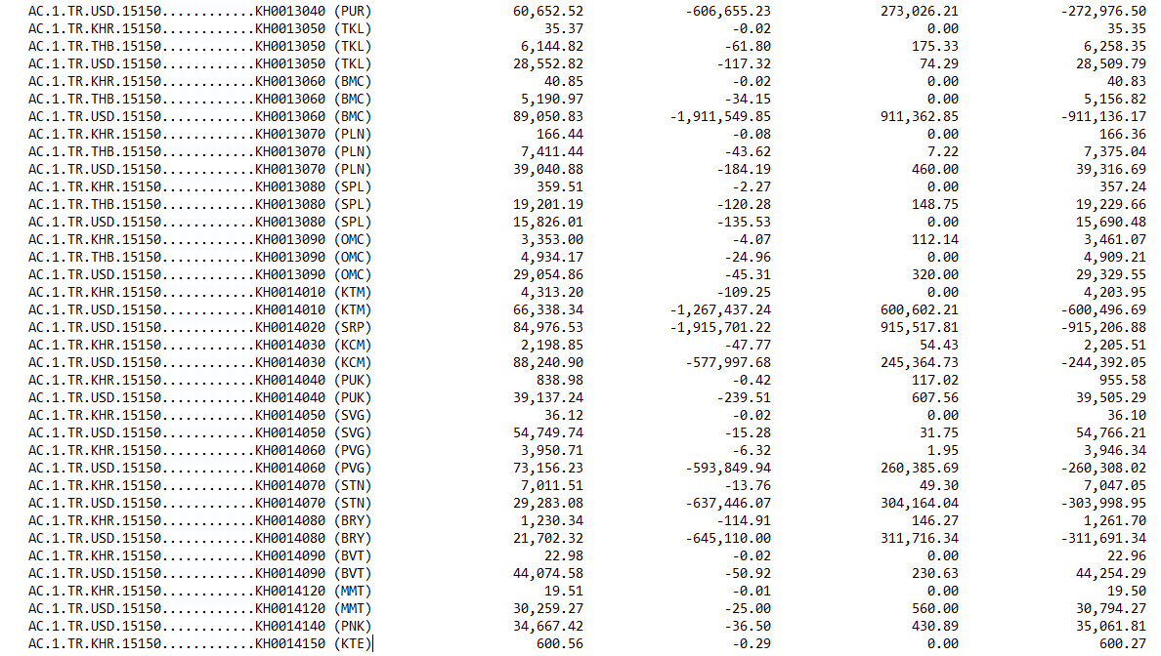 

**USD1515000014020-SRP**

**Normal Provision on Loans-Standard**

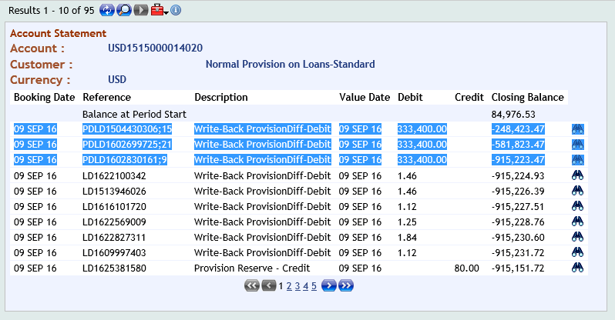

**220000037265-CHAN NARITH-2000004807**

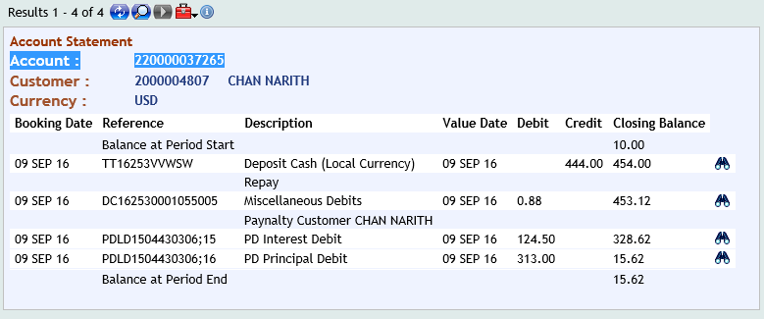

**LD1504430306-CHAN NARITH**

